ModAmerica Exam
Name:
Institution affiliation:

ModAmerica Exam
1
Progressives. What do you find remarkable about the era of Progressivism? Describe three particular leaders or movements and show how they help define this time period. How did the Progressives shape the society we live in today?
Progressive era connotes the period in which many Americans sought ways for addressing the socio-economic challenges facing the populace using alternative means other than Darwinism. It was no longer survival for the fittest mantra in the era that lasted from around 1895 to 1920. Instead, a significant majority of leaders initiated political and economic reforms (monetary policies) that created a balance in the society. The objective was advancing the interest of all as highlighted in the image below affirming the significance of innovations that led to economic liberalization. As a result, the era promulgated the adoption of progressive social and economic reforms that shaped the political landscape of America for years hence the reference to the period as progressivism.
The society managed to eliminate vices such as poverty through innovation as highlighted in the picture below. As shown by the woman entering the car, movement of families became easier as the country developed its road infrastructure. Education also paved the way for advancement in the social sphere, as well as, agricultural activities. The image below also affirms that the era marked the commencement of enlightenment and advancement of equality campaign in the United States. The era was also characterized by a drastic shift in ideological thinking from advancing individualism to promoting democratic ideals. Courtesy of the efforts, the government managed to curb corruption through the introduction of antitrust laws. There was also the rise in activism, and the numbers of scholars participating in politics increased.
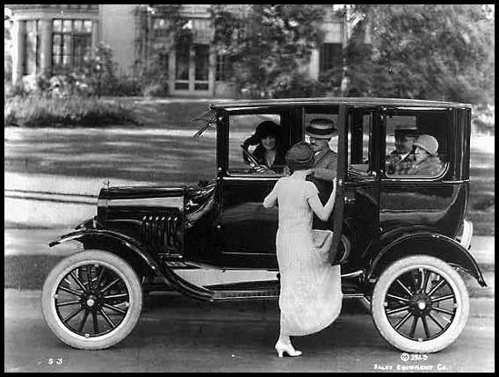
A 1920s Ford automobile

An example of a leader who proved instrumental in the era was Theodore Roosevelt, who advanced equality in economic and social spheres of the public by encouraging corporations’ activities in America. Through lobbying, the leader also managed to address corruption in government. The efforts also influenced other political leaders of the time to enact legislation supporting gender equality in the society. Activists like Booker T Washington also influenced the ratification of the constitution. The leader demanded racial equality in bid to ensure that economic policies serve the interest of all. The efforts paved the way for the establishment of philanthropic foundations striving to enhance equality. Unlike before, changes such as the 16th amendment followed making it a legal responsibility for all corporate institutions remitting taxes to the government.
Wilson Woodrow also stood out as one of the political figures instrumental in advancing the political reforms of the era. As a scholar, the leader managed to introduce tariffs in an attempt to stimulate economic policies. He believed that it was necessary strengthening the local institutions as the basis for addressing economic disparities. The efforts of the leader, together with the activities of various activists, shaped the society politically, socially and economically. To date, Americans experience the effects of the reforms that took place during the era. One such case is that the establishment of labor unions that dot the landscape today. Many took a cue from the associations established during the progressive era. Another development of the contemporary times influenced by the activities of the past is that government invests in education and research in attempt to spur social progress as the case in the past.
3
World War I. Why did the U.S. get involved in World War I? Why was it a controversial war in America? Explain Wilson's goals after the war. How successful was he?
World War 1 which commenced in 1914 involved nations such as Britain and its allies fighting the German empire. Although not directly engaged in the war at the beginning, the United States sided with Britain as it provided supplies to the former colony. The intention of joining the fight was brokering peace of which the nation managed but suffered economic consequences courtesy of Wilson’s efforts as discussed below.
The picture below highlight the situation at the battle filed. As noted, the United States failed to accomplish the goal leading to its aggression in opposing German empire. As shown in the actions of the soldiers below, the aim was averting aggressing by German empire. Another basis for the nation’s participation in the war is that it could pave the way for economic advancement, as argued out by Woodrow Wilson. Considering that opinion was divided on whether or not to join the war, it qualified as a controversial venture. Furthermore, the objective of President Wilson in lobbying the rest to participate in the war was not clear to many. Some even considered it unrealistic engaging in a war that the nation was not directly implicated. Nevertheless, the country took part in the war as manifest in the image below.
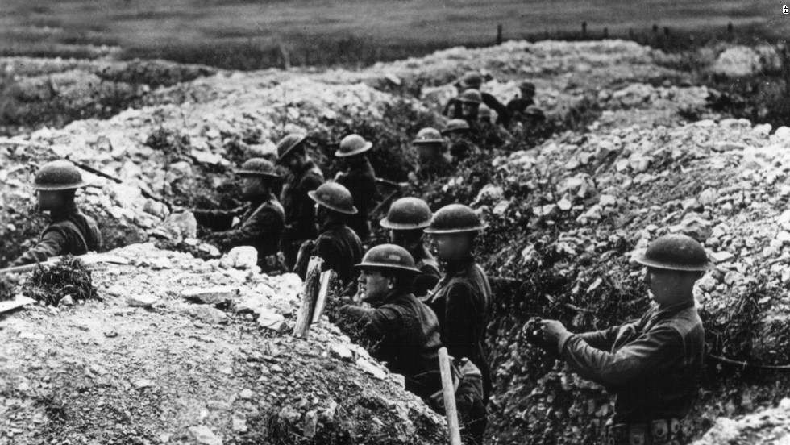Soldiers in a trench in France during World War 1
The agenda of Wilson in supporting the war was advancing socioeconomic and political reforms around the globe. According to the leader, failure to participate in the war could have jeopardized the nation’s position as the broker of peace around the globe. The quest for supremacy was also on the agenda of Wilson’s plans as he thought that Germanic empire was violating international convention treaties yet such was unacceptable. Therefore, in an attempt to bestow the pride of America after suffering casualty from the actions of German in its territorial waters, the leader advanced the war as the pathway to global liberalization.
At the end of the war, the leader managed to accomplish his objective of unifying nations’ in the quest for peace through the formation of League of Nations. According to the organization, it was agreed that no nations had the moral right to violate the sovereignty of the other since such precipitated the war in the first place. The second accomplishment of the leader was that the United States claimed credence in the global sphere as the broker of peace amidst warring nations. Even though the League of Nations was not formed in accordance with the leader’s term, the President managed to sway public opinions in support of his ideas of restoring democracy globally. In addition to gaining respect from neighboring states as Mexico through the use of force, America came out as a democratic society albeit participating in war. The above picture serves as the reminder of the experiences of the efforts of soldiers that culminated in social and economic changes in United States at the height of Wilson’s presidency.
5
The 1920s. What happened in America during the 1920s? Why do historians see the 20s as the beginning of "modern times"? Address social, cultural, economic and political factors.
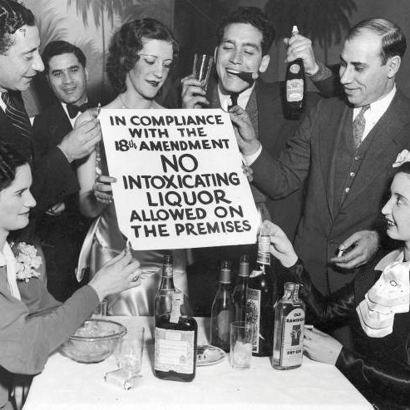
Picture of American in 1920’s
The 1920’s marked the commencement of an economic boom, inventions, and religious advances that led to the enlightenment of the latter years in the United States. As a result, the socio-economic transition had ramification on the landscape of the United States and the entire globe. As shown above, people celebrated the advances as the case with the legalization of liquor consumption. To date, scholars refer to the era as the epic of modernization of the United States. As noted, the socio-economic transition paved the way for Americans to rethink their ideals by embracing principles that made America a global power after depression.
The developments that commenced after the world war leading to the collapse of the economy in the subsequent decade paved the way for studies that advanced the adoption of classical economic concepts. The boom that opened the market encouraged the people to exploit the opportunities in the American market resulting in the destabilization of the economy.
Historians consider the 1920s the commencement of modern times due to the revolutions that were taking place at the time. From advancement in Protestantism to agriculture to trade, people were devising ways of employing new concepts in life and technology in agriculture. The practice was in contrast to the trend before the 1920s where there was minimal mechanization in farming and transportation. Another development of the era that led to it refers as the modern age was the increase in production of automobiles that contributed to the demand for fuel. The action, in turn, had numerous ramifications on the social landscape of the country.
Liquor trade legalization among many other economic activities began benefiting the people as highlighted above. Subsequently, some of the manufacturers began recording an increase in earnings from the oil exploration activities. The demand for the commodities, in turn, fuelled economic growth. The expansion of the transport sector lead to growth in urban centers as people could move to their places of work with ease. The communities also created opportunity for people to explore transportation business. The automobile industry expanded in the era hence the reference to the modern times since the developments paved the way for innovations that revolutionized the 20th century.
On the cultural front, the people from various backgrounds gathered together in social places to worship or celebrate event as depicted in the photo above. The workplace also became the center for exchanging ideas. Due to immigration, people began embracing ideals that appealed from other cultures. Although, the action resuscitated conflict in did affect the lives of Americans in many ways. Quest for association in the 1920s encouraged people to join association to lobby for their interests. As a result, the trends led to the stabilization of the political parties. The democrats and the republicans take credit for the stability of their institutions in the era.
7
New Deal. Explain how Franklin Roosevelt proposed to help the economy. Why was he able to make so many changes? What lasting impact did New Deal policies have on America?
The new deal is the idea advanced by progressive’s such as Roosevelt who sought for ways for preventing the possibility of occurrence of depression once more. The deal encompassed programs steered by Roosevelt that managed to streamline the economic and political landscape, thus setting precedence for future endeavors. As manifest in the image below, President Roosevelt is spearheading construction of Panama Canal in attempt to spur trade; thus creating balance in the economy.
According to Roosevelt’s proposal as part of the new deal, the liberalization of the economy was critical in addressing poverty and unemployment that characterized the early thirties. To the leader, the ideal way of doing so entailed setting agencies to monitor the activities of financial institutions in the country. Roosevelt also proposed the Economy Act that sought to reduce budget expenses by cutting salaries for state officials. He also proposed the fiscal policy of using the government as the regulator of spending in the country.
Unlike many of his predecessors, the leader was able to make several changes since he had the support of the Congress. The leaders had also worn the trusts of the public through the elections leading to his participation in development activities as the one depicted in the image below. The advancement of Keynesian economic ideals that encouraged reduction in spending by the government also made it possible for the leader to ratify numerous legislations. Additionally, the country was beginning to record progress after the depression and as such it was easier advancing economic ideals that sought to regulate the financial sector.
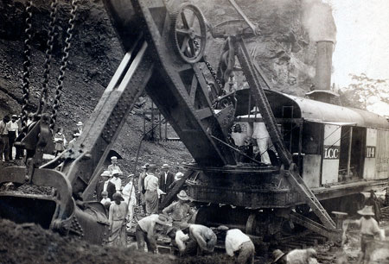
The picture depicts Roosevelt participation in the construction of Panama Canal. (1908)

The lasting impact of the new deal has been introduction of Acts that strive to regulate the activities of bank in the United States in times of economic difficulties as the case during the recession of the last decade. At most, the nation adjusts interest and regulates currency in an attempt to address cases of unemployment as the case during the era of the deal. Additionally, governments advance fiscal and monetary policies concurrently as the measure to curb the imbalance in economic growth. Another lasting impact is that governments strive to encourage participation in agriculture and manufacturing as the strategy for averting the possibility of hunger affecting the populace. In dealing with inequality in the country, the legislators lobby for support from the public in amending laws and introducing programs that benefit all. Such was the case in 2009 when Obama administration sought to support of the public in introducing reforms in the housing sector. The government sought to place caps on interest for homes to prevent the possibility of the imbalance halting recovery.

Reference
Norton, M. B., Kamensky, J., Sheriff, C., Blight, D. W., & Chudacoff, H. (2014). A People and a Nation, Volume II: Since 1865. Nelson Education.

